**9 SCIENCE 2016**

### BIOLOGY TEST ONE

Name: ____________________ Teacher: ___________________ Mark: /44

**Percentage: %**

**SECTION A: MULTIPLE CHOICE (25 marks)**

**Please answer on the multiple choice answer grid below.**

1. A B C D 13. A B C D

2. A B C D 14. A B C D

3. A B C D 15. A B C D

4. A B C D 16. A B C D

5. A B C D 17. A B C D

6. A B C D 18. A B C D

7. A B C D 19. A B C D

8. A B C D 20. A B C D

9. A B C D 21. A B C D

10. A B C D 22. A B C D

11. A B C D 23. A B C D

12. A B C D 24. A B C D

25. A B C D

**Questions 1 – 3 refer to the scenario below.**

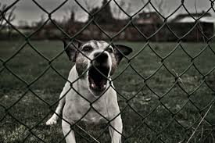

Casey is walking down the street when a dog behind a fence barks loudly and Casey jumps from fright.

**1.** When Casey gets frightened suddenly by the dog barking, which nervous system is activated?

(a) Parasympathetic nervous system.

(b) Somatic nervous system.

(c) Sympathetic nervous system.

(d) Central nervous system.

**2.** The nervous system activated affects the body in numerous ways. Select the most likely symptoms that Casey will experience.

(a) Dilated pupils, inhibited digestion, contracted bladder.

(b) Relaxed bladder, inhibited digestion, dilated pupils.

(c) Stimulated digestion, constricted pupils, accelerated heart rate.

(d) Slowed heart rate, contracted bladder, dilated pupils.

**3.** Select the nervous system that works to calm Casey and maintains an appropriate energy level for normal bodily functioning.

(a) Parasympathetic nervous system.

(b) Central nervous system.

(c) Sympathetic nervous system.

(d) Somatic nervous system.

**4.** Select the most correct description for the term ‘pathogen’.

(a) A type of antibiotics.

(b) A disease-causing multicellular organism.

(c) A disease-causing unicellular organism.

(d) A type of disease.

**5.** Lymph nodes contain two types of white blood cells that destroy pathogens. They are:

(a) Macrophages and lymphocytes.

(b) Lymphocytes and neutrophils.

(c) Neutrophils and macrophages.

(d) Neutrophils and erythrocytes.

**6.** All the glands in the body together are known as the:

(a) Endocrine system.

(b) Lymphatic system.

(c) Excretory system.

(d) Nervous system.

**Answer questions 7 and 8 based on the diagram below.**

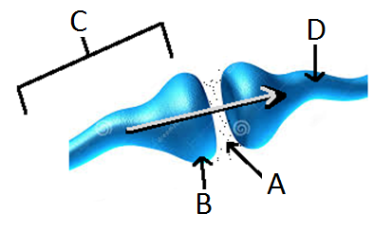

**7.** The diagram shows:

(a) A synapse between two neurons.

(b) A synapsis between two nerves.

(c) A knee joint.

(d) A synopsis between two neurons.

**8.** Label ‘A’ in the diagram refers to:

(a) A vacuum

(b) The neurotransmitter.

(c) The axon.

(d) The neuron.

**9.** Choose the correct definition for ‘target cells.’

(a) The cells that hormones act on.

(b) The cells that secrete hormones.

(c) Endocrine glands.

(d) The cells that enzymes act on.

**10.** Select the incorrect statement below.

(a) Nerve impulses can only travel in one direction.

(b) Nerve impulses are electrical messages carried by a nerve cell.

(c) The nervous system is made up of hundreds of nerve cells.

(d) Electrical messages are also known as nerve impulses.

**11.** A receptor is a specialised nerve. The main function of the receptors is:

1. Send messages from the brain to the muscles
2. Carry out a response
3. Send messages to the central nervous system from an organ
4. Detect a stimulus

**12.** The hypothalamus regulates:

1. Heart rate.
2. Water balance.
3. Body temperature.

(d) All of the above.

1. 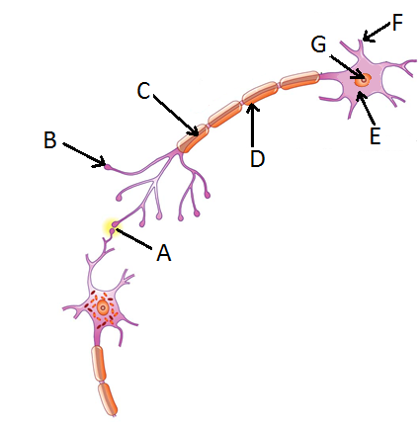**Question 13 – 16 refer to the diagram on the right.**
2. **13.** Label ‘F’ is pointing to:

(a) A dendrite.

(b) An axon terminal.

(c) The axon.

(d) The myelin sheath.

**14.** The cell body is marked by label:

(a) A.

(b) E.

(c) G.

(d) F.

**15.** The axon terminal is marked by label:

(a) C.

(b) B.

(c) F.

(d) A.

**16.** Label ‘D’ is pointing to:

(a) Cell body.

(b) Axon.

(c) Myelin sheath.

(d) Dendrite.

1. **17.** Name two parts of the autonomic nervous system.
2. central nervous system and parasympathetic nervous system
3. sympathetic and parasympathetic nervous system
4. central nervous system and peripheral nervous system
5. peripheral nervous system and parasympathetic system.

**18.** Describe the relationship between the hypothalamus and the pituitary gland.

(a) The pituitary is called the “master gland”. The hypothalamus responds to messages from the pituitary gland.

(b) The hypothalamus secretes hormones that act on the pituitary gland which is also known as the “master gland”.

(c) The hypothalamus is part of the brain and the pituitary gland is located in front of the trachea in the neck.

(d) The hypothalamus constantly checks the conditions within the organs and systems of the body. The pituitary gland checks the activity of the brain.

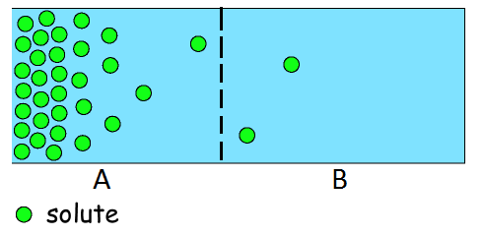

1. **Question 19 – 21 refer to the diagram on the right.**

**19.** What is the name of the process that allows the solute particles to move between the membrane in the container of water shown in the diagram above?

(a) Circulation.

(b) Concentration.

(c) Diffusion.

(d) Dissolving.

**20.** The process that is occurring in the diagram can be defined as:

(a) The movement of particles from low concentration to high concentration.

(b) The movement of particles from high concentration to low concentration.

(c) The movement of particles that require energy to move.

(d) The movement of particles from an area of lower temperature to an area of higher temperature.

**21.**  The solute from side A will:

(a) Stay in side A because there is a lower concentration of the solute there.

(b) Move to side B where there is a lower concentration of the solute there.

(c) Stay in side A because there is a higher concentration of the solute there.

(d) Move to side B where there is a higher concentration of the solute there.

**22.** During gas exchange in the alveoli of the lungs, ________ moves from the capillaries into the alveoli and _________ moves from the alveoli into the capillaries.

(a) Carbon dioxide; oxygen.

(b) Oxygen, blood.

(c) Glucose, carbon dioxide.

(d) Oxygen, carbon dioxide.

**23.** Identify the **correct** definition of “homeostasis”

(a) The maintenance of a constant internal environment

(b) The ability to react to changes in the internal environment

(c) The releasing of hormones that react to certain stimuli

(d) A pair of hormones that work together and react in opposite ways

**24.**  The small patch of muscle in the heart that initiates the heartbeat cycle is called:

(a) The pulsemaker.

(b) The arrhythmias.

(c) The heart generator.

(d) The pacemaker.

**25.** Select the list of endocrine glands.

(a) Pancreas, ovary, thyroid, pituitary gland.

(b) Pancreas, kidney, testes, pituitary gland.

(c) Thyroid, parathyroid, ovary, bladder.

(d) Adrenal gland, thyroid, hypothalamus, ovary.

**SECTION B: SHORT ANSWER (19 marks)**

**21.** State two functions of the liver in regards to removing wastes. (2 marks)

_____________________________________________________________________________________

_____________________________________________________________________________________

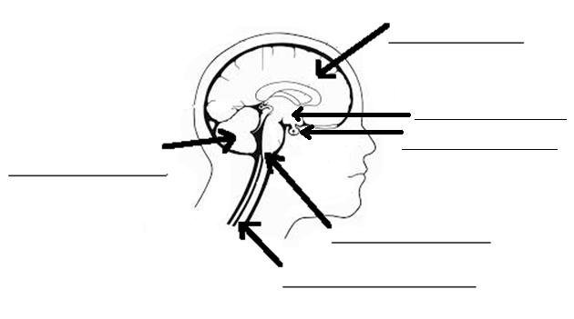**22.** Label the diagram below. (6 marks)

**23.** Glands that produce hormones are known as: (1 mark)

_____________________________________________________________________________________

**24.** Write a definition for the term ‘enzymes’. (1 mark)

_____________________________________________________________________________________

_____________________________________________________________________________________

**25.** Your body has three lines of defence against disease. (3 marks)

1. Prevent the _________________________ from entering the body.

2. __________________________ of the affected area occurs.

3. The ________________________ system releases white blood cells to destroy pathogens.

**26.** Two students were testing the effectiveness of an enzyme on breaking down proteins into amino acids. When protein is broken down into amino acids it turns clear.

The students had two test tubes in a water bath (container with water). Both of the test tubes had some egg white (protein) in the bottom. One of the test tubes also had an enzyme called protease added to it. The test tubes were placed in a water bath and left there for 20 minutes.

They repeated the experiment three times. Their set up is shown below:

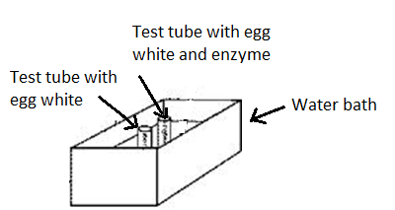

After 20 minutes they obtained the following results:

|  |  |  |
| --- | --- | --- |
| Trial | With enzyme | Without enzyme |
| 1 | Turned Clear | Remained white |
| 2 | Turned Clear | Remained white |
| 3 | Turned Clear | Remained white |

**a.** State the independent variable in this experiment. (1 mark)

_____________________________________________________________________________________

**b.** State the dependent variable in this experiment. (1 mark)

_____________________________________________________________________________________

**c.** List two variables that should be controlled. (2 marks)

_____________________________________________________________________________________

_____________________________________________________________________________________

**d.** Explain what they could conclude from the results they obtained. (2 marks)

_____________________________________________________________________________________

_____________________________________________________________________________________

_____________________________________________________________________________________

_____________________________________________________________________________________